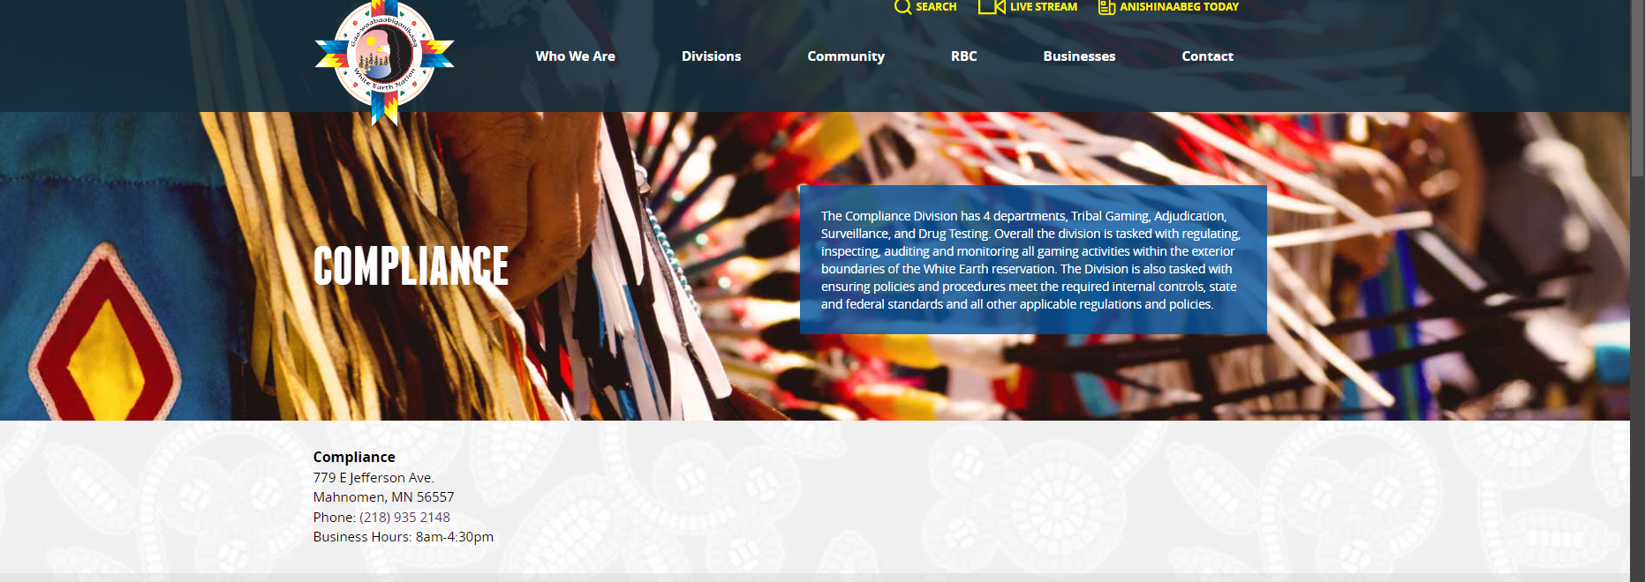
The Compliance Division is made up of 4 diverse departments - Tribal Gaming, Adjudication, Surveillance, and Drug Testing. Overall, the division is tasked with regulating, inspecting, auditing and monitoring all gaming activities within the exterior boundaries of the White Earth Reservation along with their main role of ensuring policies and procedures meet the required internal controls, state and federal standards and all other applicable regulations and policies. The Division also provides strategic support of all programs, boards, and entities with their individual unique services.
Our Mission - To promulgate comprehensive and effective services to the people of the White Earth Nation for their economic needs with respect for their cultural individuality and encourage their talents knowledge and skills to move the White Earth Nation forward.
Our Vision - Together the Compliance Division strives to achieve a vision of success for future generations and to preserve and protect the integrity of gaming, employment procedures and policies, while safeguarding all assets for the White Earth Nation, our people and our communities, now and in the future.
Compliance Director
Christie Haverkamp
Office (218) 935-3962 Cell – (218) 850-7842
email : Christie.Haverkamp@whiteearth-nsn.gov
Main office Front Desk ( 218) 935-2148

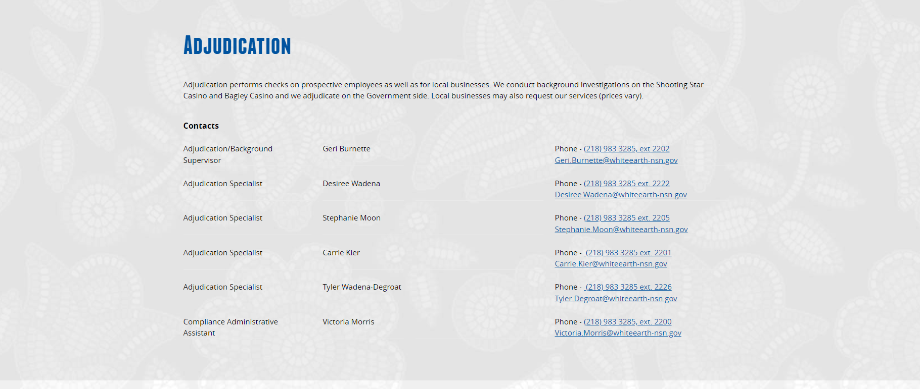
Adjudication performs background checks on all applicants for the Shooting Star Casino and Adjudications for the Tribal Government, Clients and Contractors .
Local businesses may also request our services (prices vary), please contact Geri Burnette for information.
We offer ink rolled fingerprint services to the public at a cost of $10.00 per card. Must supply fingerprint card when services are needed.
Applications are available for Waabigwan Mashkiki and the White Earth RBC in our main lobby area.
Add SSC Application (file attached SSC Application)
Add NTOGE (off-site) Gaming Application (file attached WE Gaming Application)
Adjudication Contacts
Adjudication Manager/TAP – Geri Burnette – 218-935-3969 – Geri.Burnette@whiteearth-nsn.gov
Adjudication Specialist/TAP – Desiree Wadena – 218-935-3973 - Desiree.Wadena@whiteearth-nsn.gov
Adjudication Specialist/TAP – Tyler Wadena-DeGroat – 218-935-3971 - Tyler.Degroat@whiteearth-nsn.gov
Adjudication Specialist/TAP – Carrie Kier – 218-935-3974 - Carrie.Kier@whiteearth-nsn.gov
Background Technician – Victoria Morris – 218-935-3970 - Victoria.Morris@whiteearth-nsn.gov
Administrative Assistant – Natasha Lafriniere – 218-935-3694 - Natasha.Lafriniere@whiteearth-nsn.gov
Our office is located at the Main Compliance offices
779 E Jefferson Ave
Mahnomen , Mn 56557

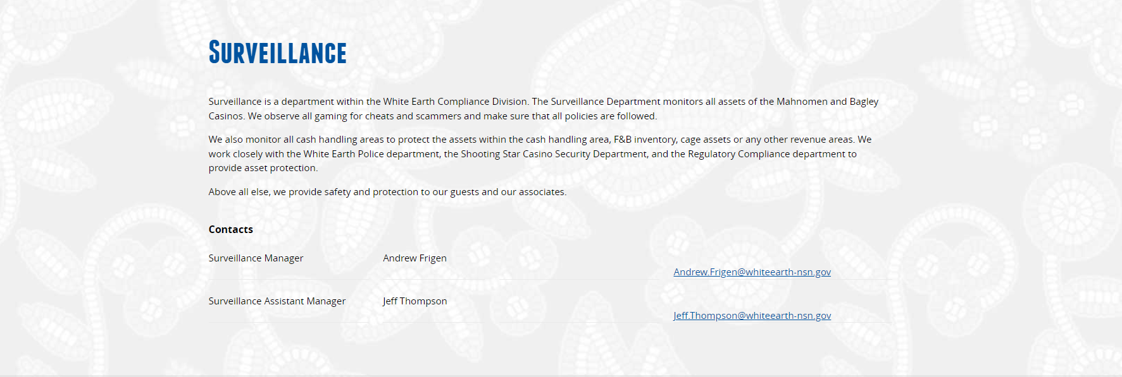

Surveillance monitors, installs and repairs camera and video equipment for all entities of the White Earth Reservation.
Surveillance works closely with all programs on installing camera and recording equipment for all Tribal buildings. We provide advice on placement and ensures all of our Surveillance equipment is up to date and working properly. We report and review incidents with 24/7 monitoring for all White Earth buildings including those of off reservation.
Above all else, we provide safety and protection for our guests and our associates.

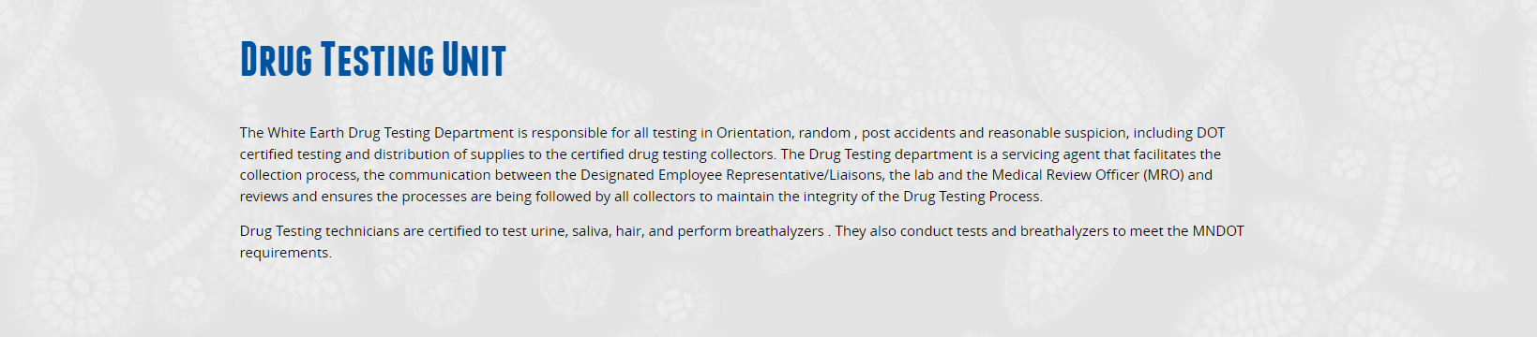

Please Add
Directors / Managers /Supervisors please contact (218) 204-0681 to request a post accident

Drug Testing Manager
Tina Starkey
Office (218) 935-3803
email : Tina.Starkey@whiteearth-nsn.gov
Main office Front Desk ( 218) 935-2148

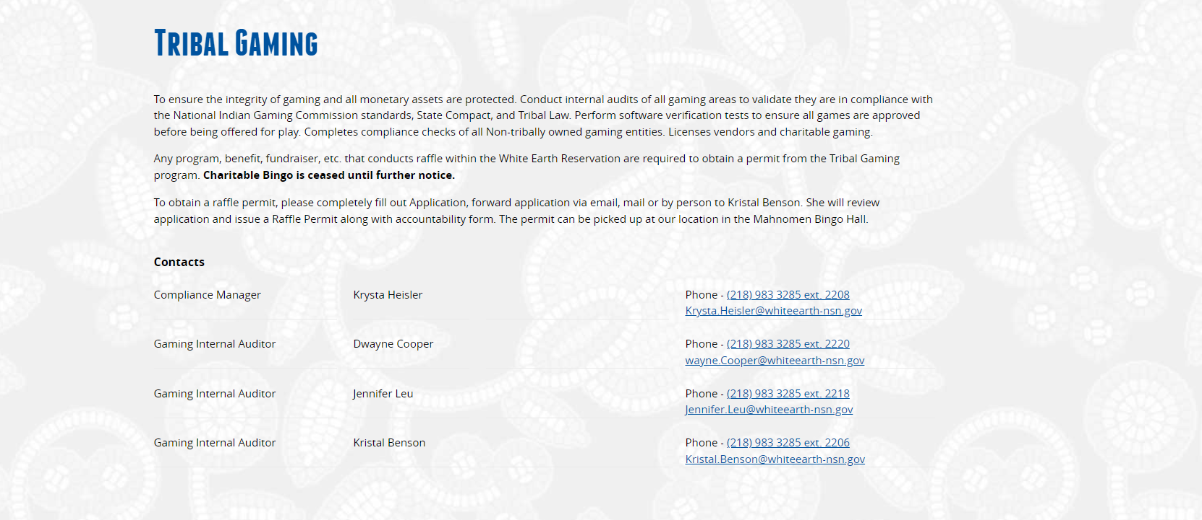

To ensure the integrity of gaming and all monetary assets are protected, we conduct internal audits of all gaming areas to validate they are in compliance with the National Indian Gaming Commission standards, State Compact, and Tribal Law. We perform software verification tests to ensure all games are approved before being offered for play and completes compliance checks of all offsite gaming entities. Tribal Gaming licenses vendors , facilities and charitable gaming.
Charitable Bingo and Pull Tab Events are permitted and are required to follow White Earth Gaming Regulations. Contact the Tribal Gaming Department for more information.

Our office is located at the Main Compliance offices
779 E Jefferson Ave
Mahnomen , Mn 56557

Compliance Manager
Krysta Heisler
Phone – (218) 935-3963
Krysta.Heisler@whiteearth-nsn.gov

